***Girdlestone, Tahurangi and SSBRI***

**17 October 2020**

**~~Trampers~~ ~~Climbers~~ Yes: Kyle Zhou, Jason Rosinger, Lucy Chen**

The middle of October isn't generally the time you go to Ruapehu for ice climbing, so the general mood when I proposed doing exactly that was one of confusion and disinterest. It hadn't been the most snowy season, and lockdowns had made off with what little of it had been. It seemed like folks were happy to call it a day and just go back to sport climbing.

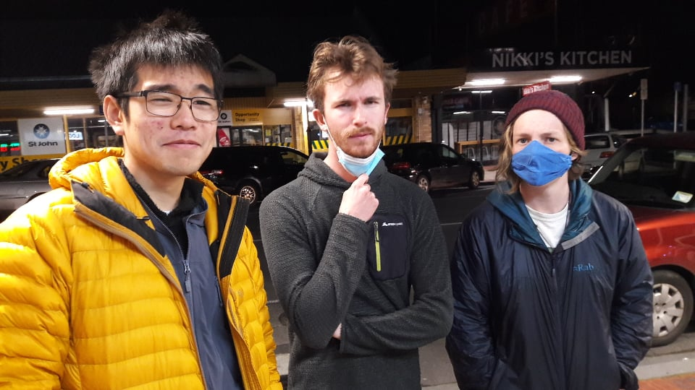

*Press* ***ⓧ*** *to doubt*

Fortunately, I managed to swindle some friends of mine into coming down with me and having a go. There was a recent storm and consistent southerly winds had kept freezing levels low since then. But more importantly, a window for nice winter conditions (and lovely windslab) had presented itself nicely from Saturday 3AM to the evening. It was a bit of a tough sell convincing folks to get up at 3AM after driving down to the maunga and getting to bed at 11PM, and unfortunately as our friend Sascha had come down with something nasty he couldn't make it. Kyle and Lucy seemed skeptical, having never had enjoyed the dubious honour of an alpine start before, relatively fresh from their advanced snow school. 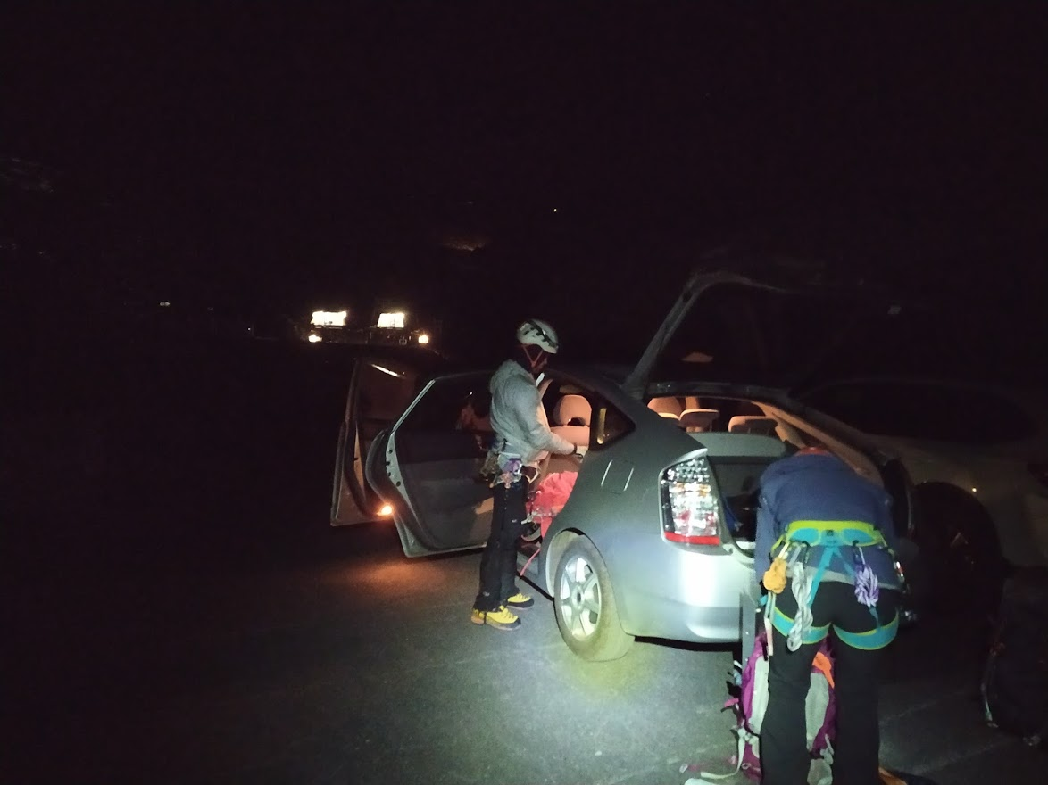

When the alarm went off at 3AM, I was hoping to be out the door 5 minutes later having packed and prepared everything the night before - but no plan seems to survive first contact with the enemy. Some time later, we began our trudge up the bare skifield at 4:15.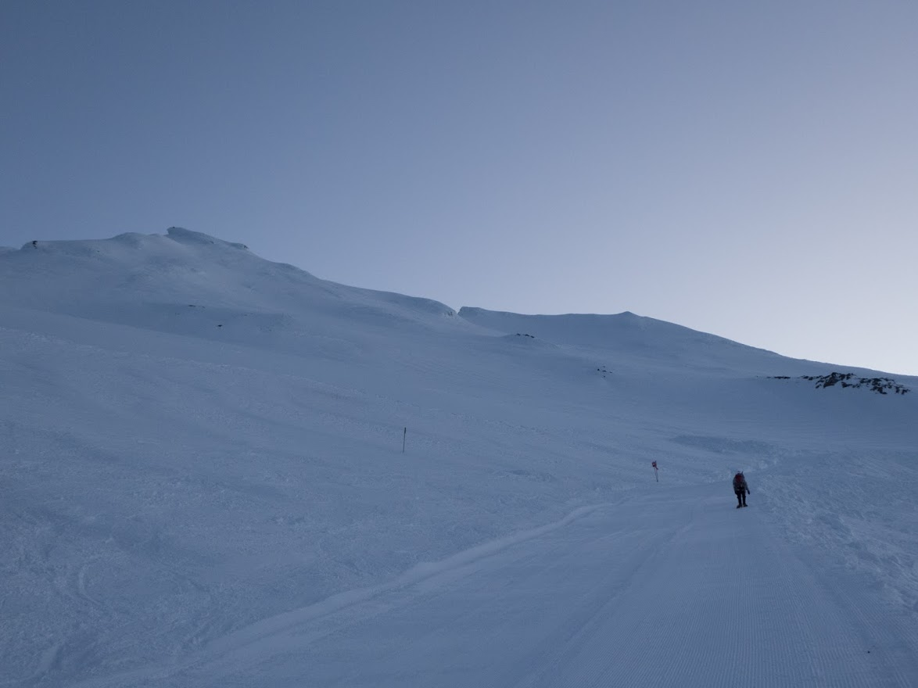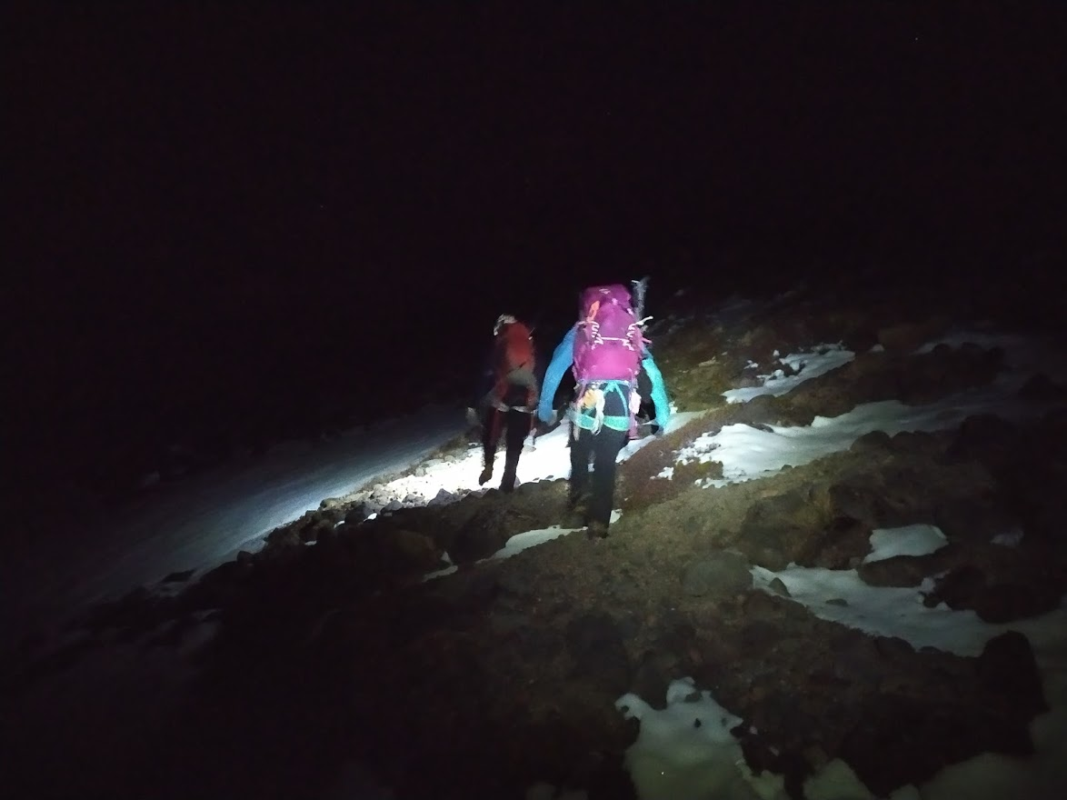

The glow of dawn raced us to the top of the high noon at 2300m. After some puffing, we'd made it there by 6AM.

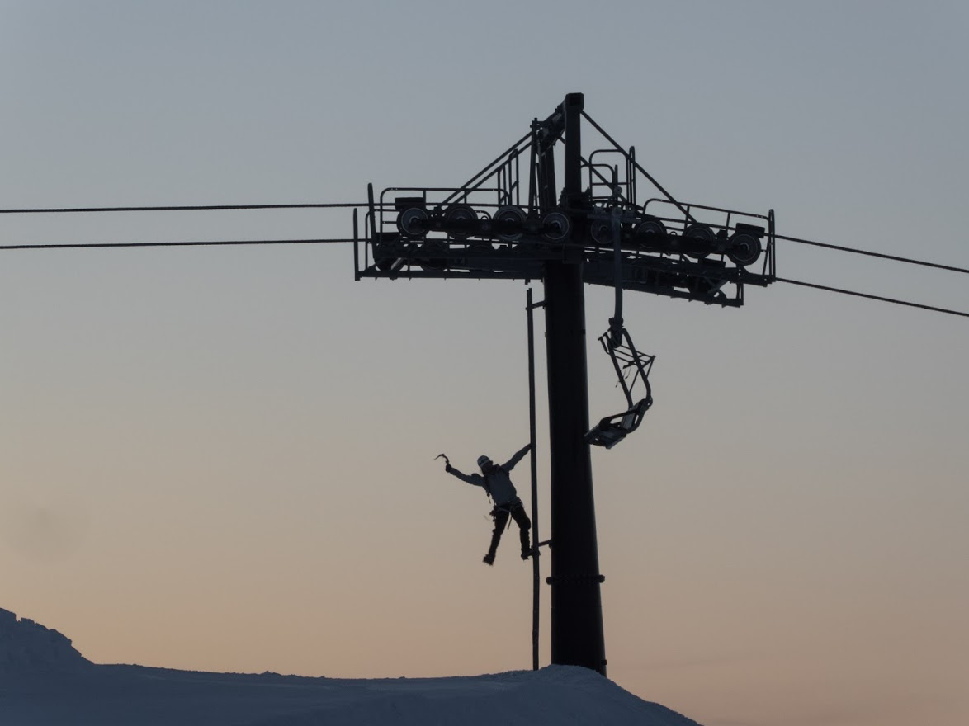

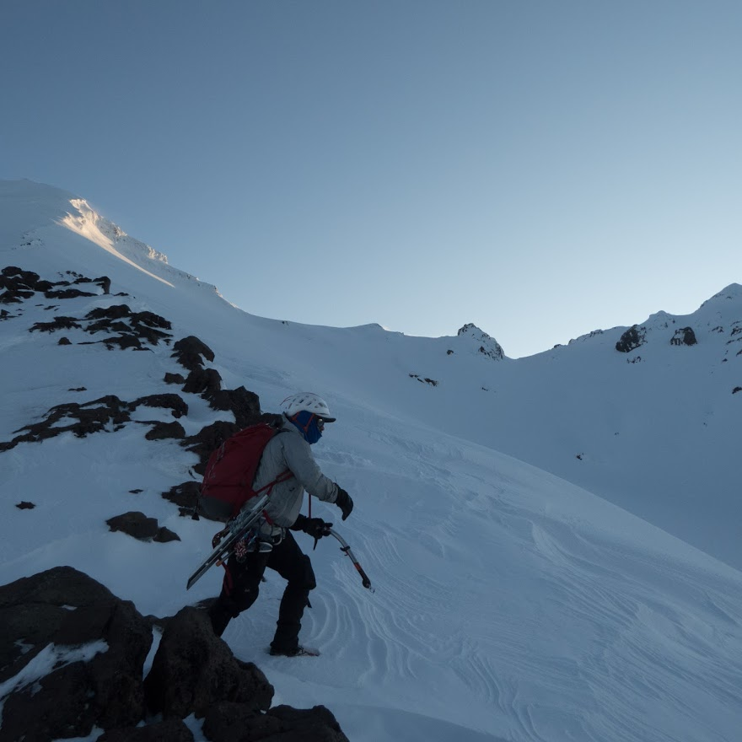

We racked and layered up in the lift house, had a brief snack and trudged off to the base of girdlestone. The off-piste conditions were inspiring, bare blue alpine ice covered with waist deep powder, and delicate wind slab in places. After some swearing and an awful lot of postholing, we arrived at

the base of the south face at 6:30.

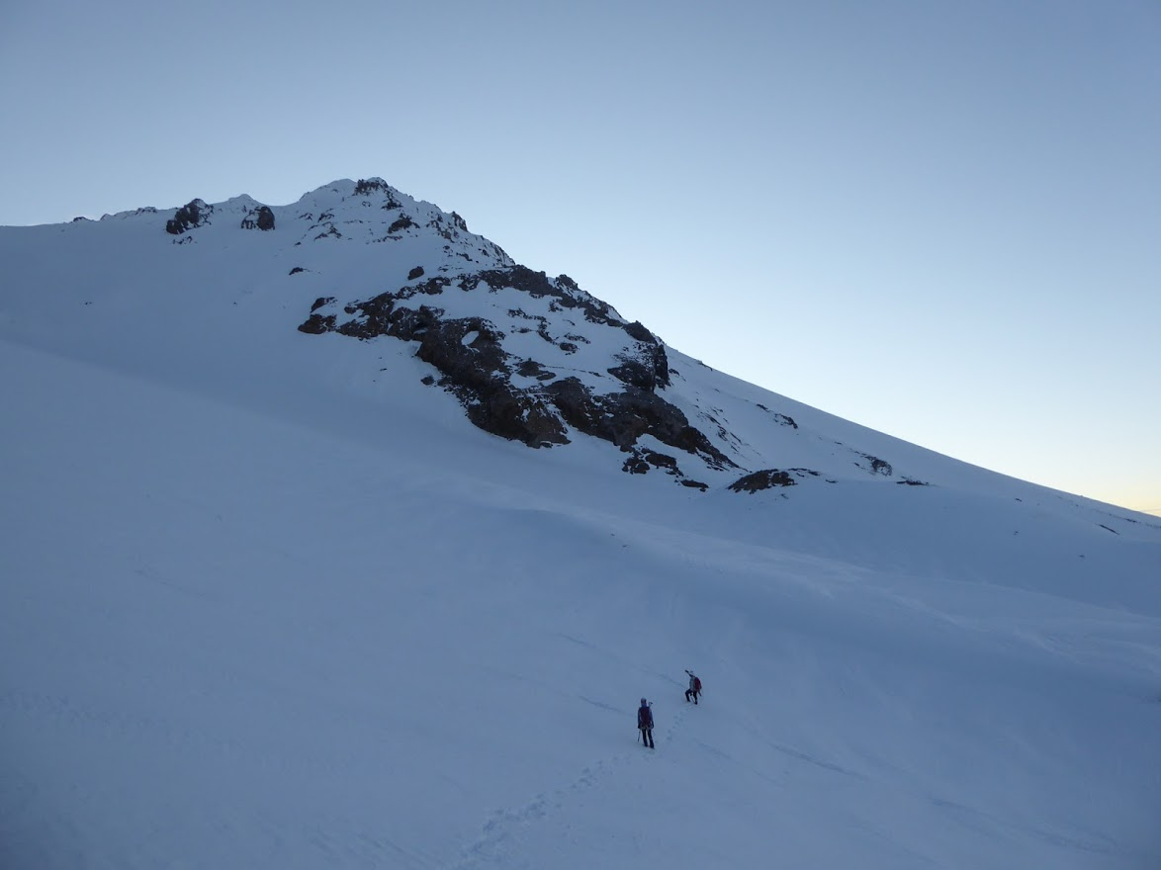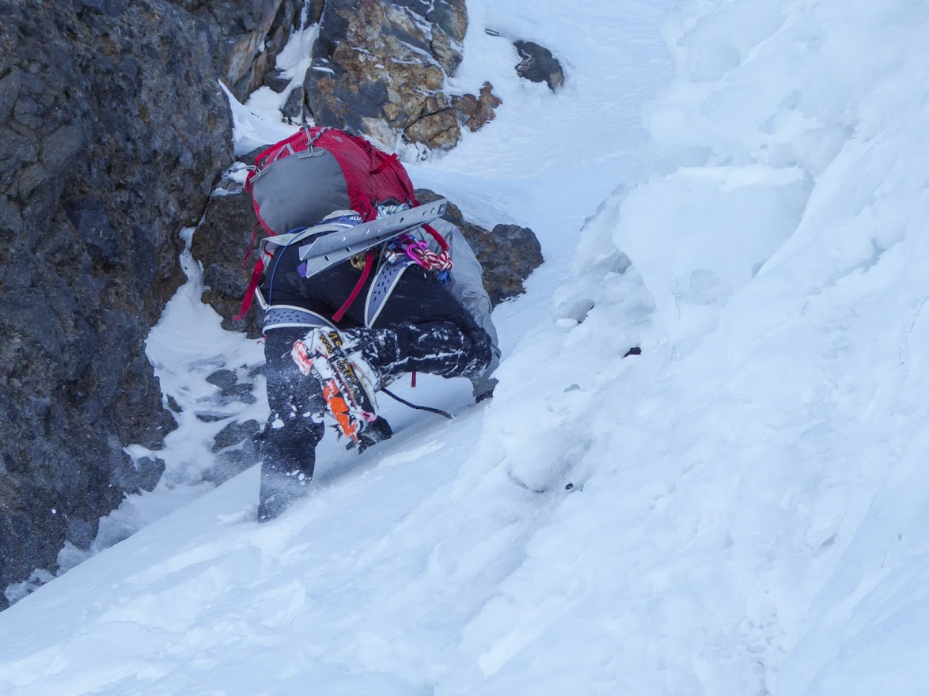

Kyle immediately charged off up an icy gully, probably equally out of being very cold and very excited. It was steep, hero ice and seemed a lot more fun than the relatively shallow snice and powder plugging.

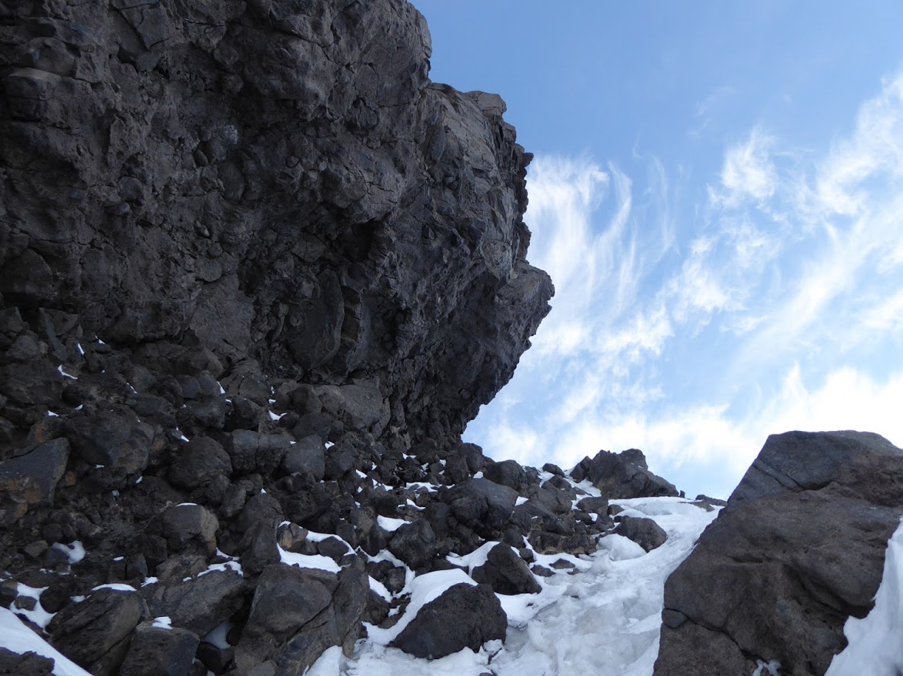

The swinging and frontpointing continued, the hero ice allowing us to make steady progress up the south face, enjoying and clambering up every steep gully we could find. The crux of the face, albeit a reasonably contrived one given the presence of a much more chill snow slope, was a steepening gully with the top 4m being 70deg ice. It was gorgeously exposed, a number of bluffs and the south face dropping away from under us for 300m. The ice was so good that no rope was necessary, but the going was still relatively slow as we were forced to go one at a time through these chutes and wait for the others, a theme that would continue for the rest of the day. 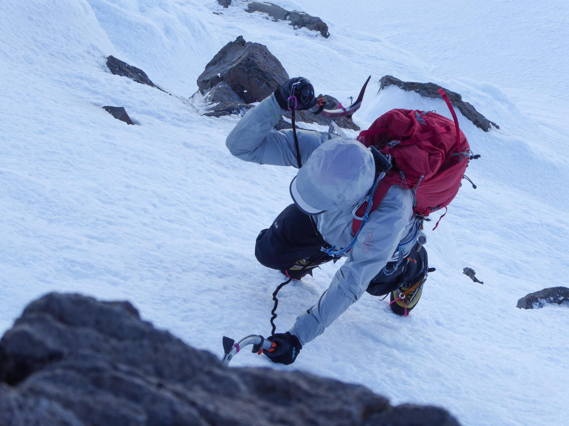

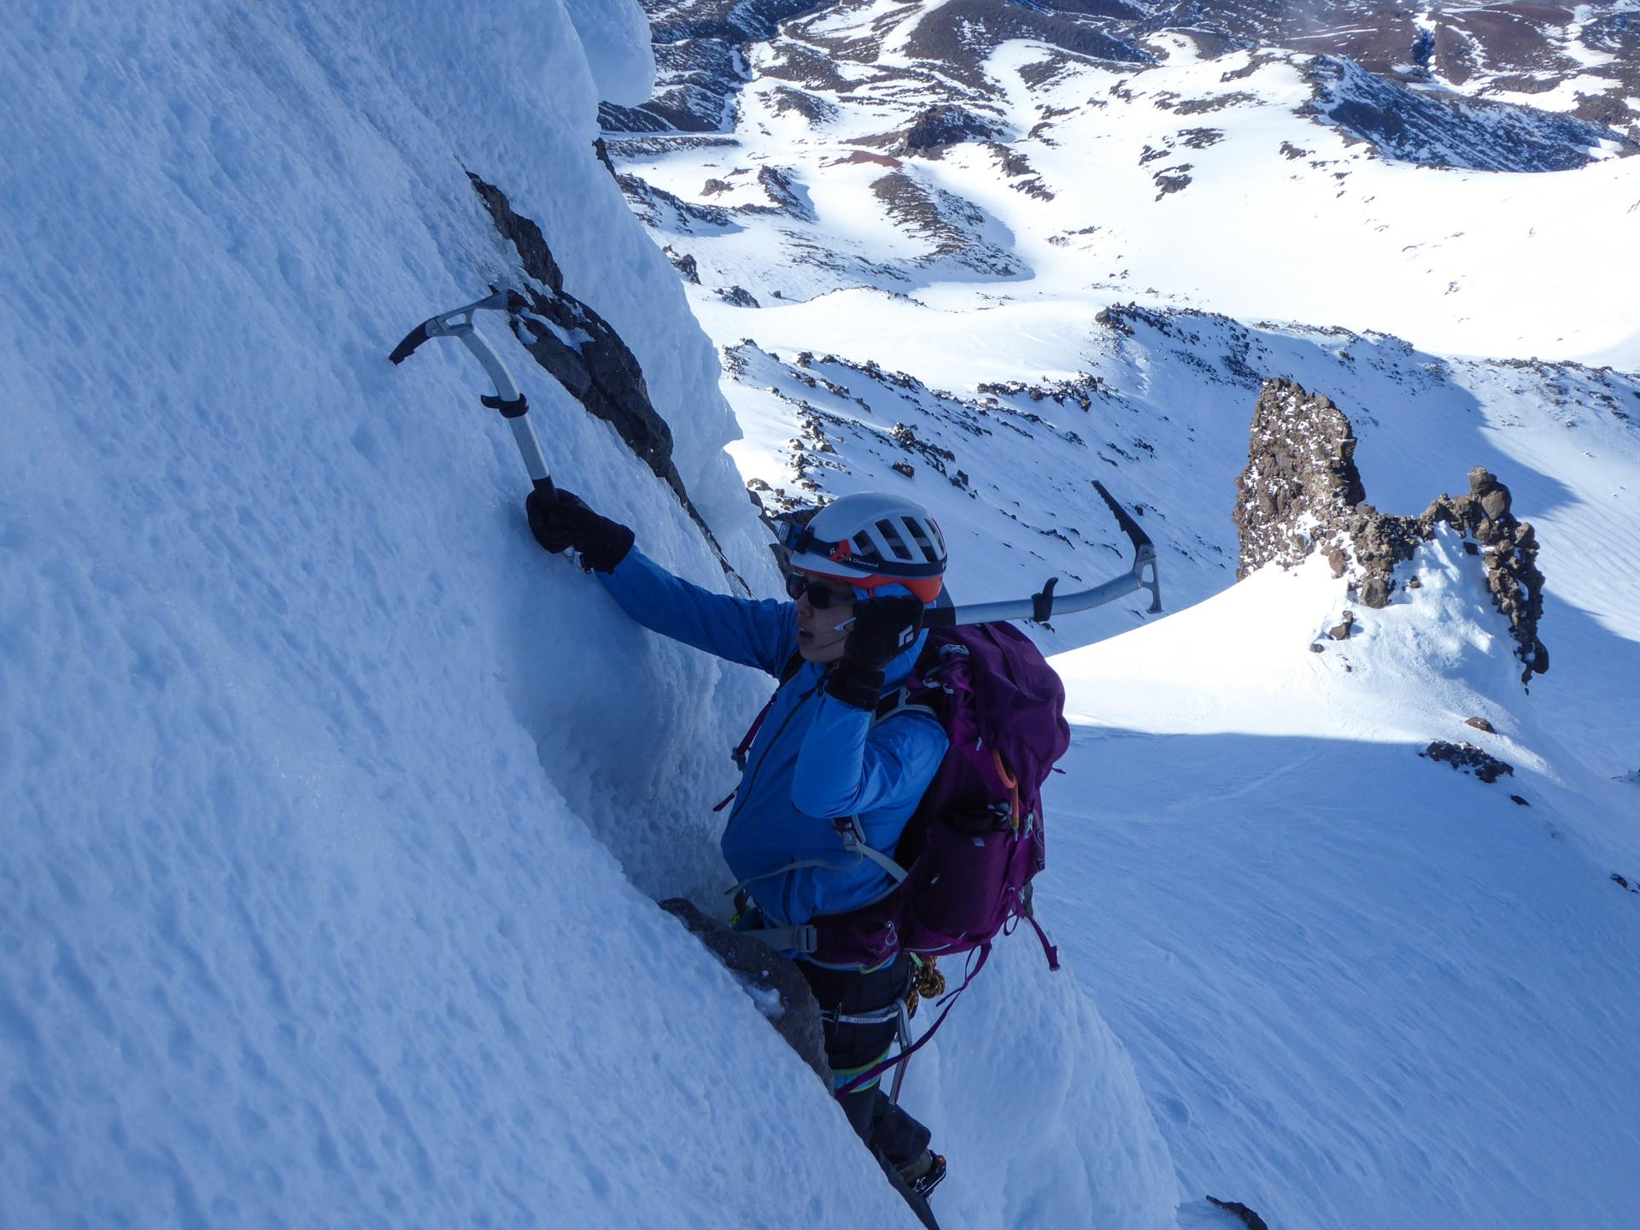

After some more modest ice gullies, we reached the summit at 8:30AM. It had turned into a giant cornice, which made for a very comfy seat once we'd busted out the bothy bag. A detail I've neglected to mention until now is that it was our friend Lucy's birthday, which we now celebrated by lighting a candle on a cake inside the bothy while singing happy birthday. It was outrageously cute and probably the highlight of our trip.

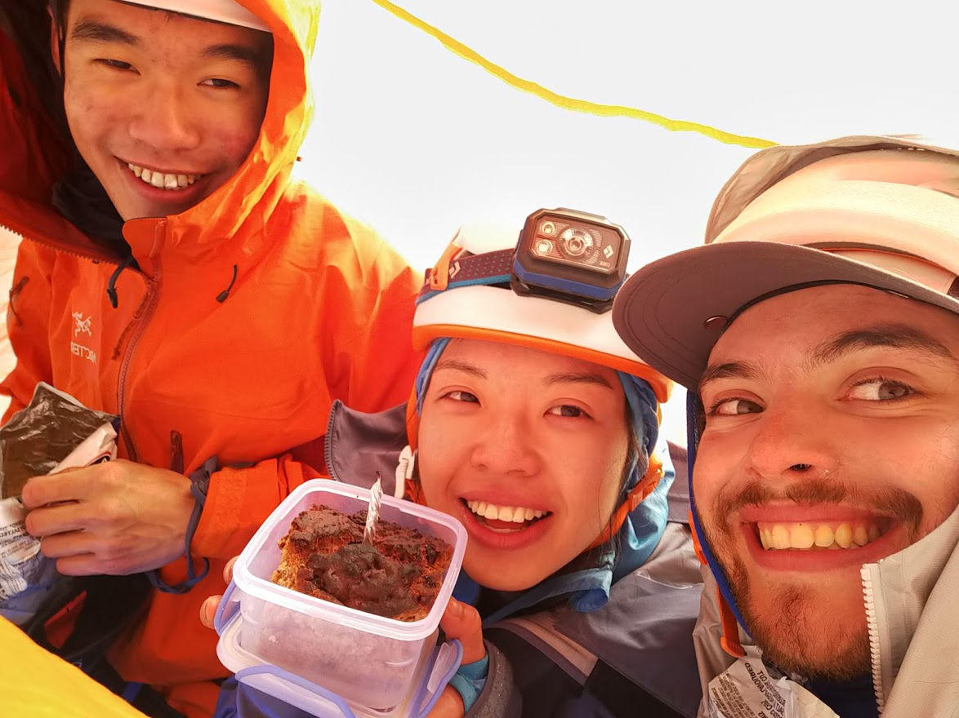

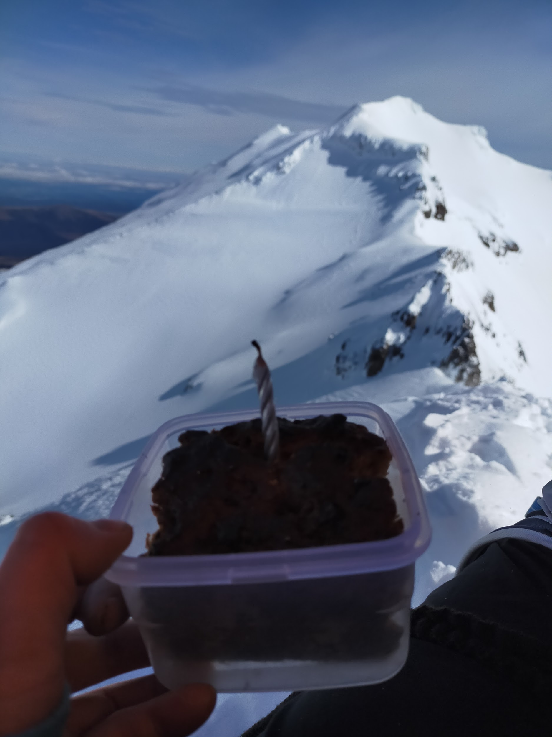

Luckily for us, we still had a lot of route ahead of us. The downclimb from girdlestone onto the ridge, the infamous Gendarme and Mangaehuehu headwall. Most parties choose to bypass these obstacles by sidling onto the Wahianoa glacier, but that didn't seem to be quite in the spirit of things and it wasn't like we were running out of daylight. As we got closer to the Gendarme, it looked like it would offer a variety of excellent climbing opportunities, and Kyle decided he wanted to climb a line of ice on the Wahianoa side (marked in blue). It was about 15m of staircase rime ice, with some 60 degree bulges. It wouldn't get us over the top but again, we had a lot of time having pitched nothing up until this point. A suitably bomber boulder was found to sling, and Kyle set off on his first ice lead.

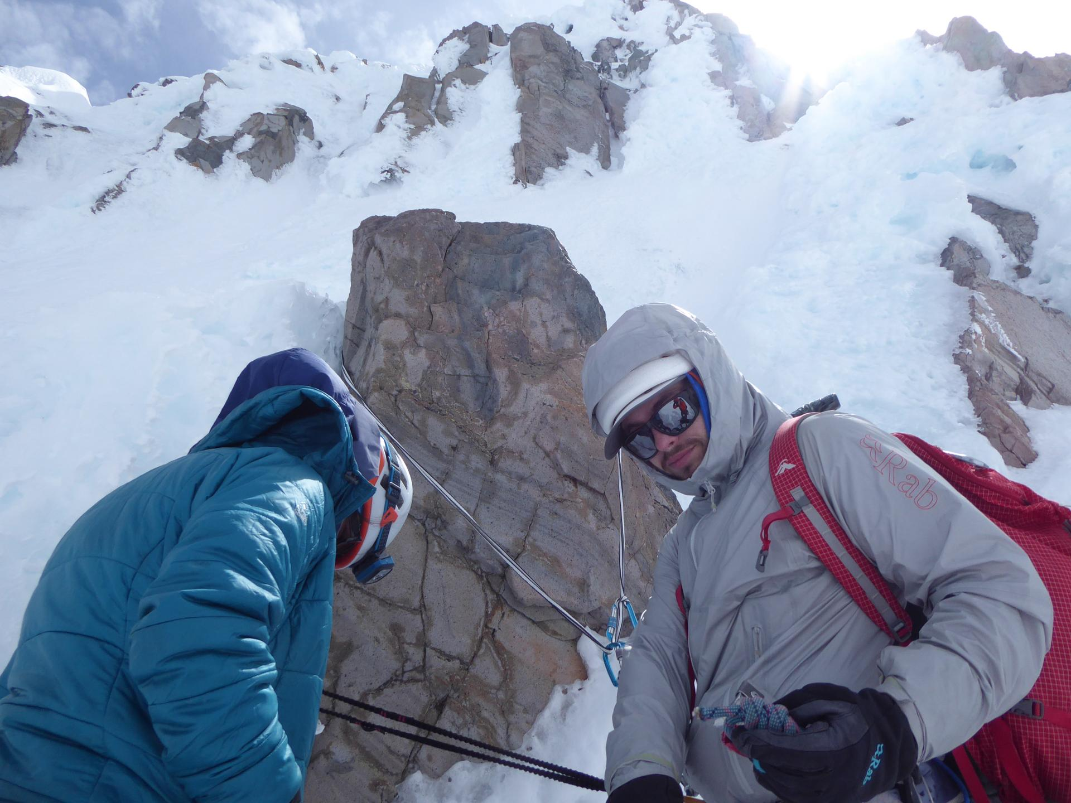

The ice proved itself to be sunbaked rotten rime (SBRRI), and regrettably finding a single trustworthy placement for our single screw proved difficult. A topclip was attempted, then followed in favour of a ruapehu classic - slung frozen choss. It was with some confusion as Kyle proceeded up that I noticed a stake appear right next to me, having embedded itself in the snow. Eventually, he topped out and realized that there was nothing that could be used to rap off, deciding to downclimb a parallel snow gully and clean gear on the way down. It was with some confusion as Kyle proceeded down that I noticed an ice screw appear right next to me, having embedded itself in the snow. After another chip-stop, we put away the rope and boosted up the central steep ice gully of the Gendarme, topping out back on the ridge. Some suffering through 40deg powder later and ice gullies, we'd reached the Mangaehuehu headwall.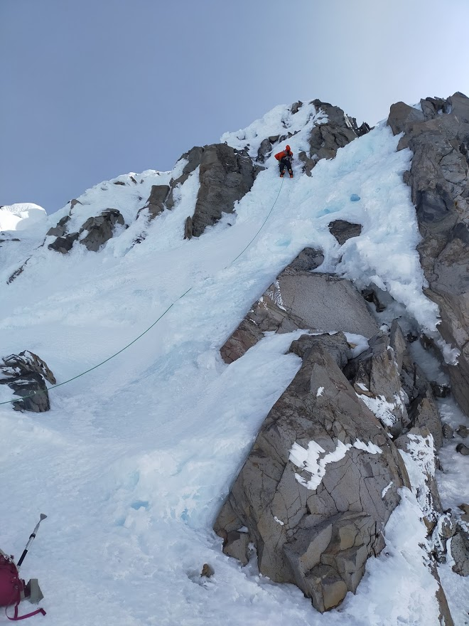

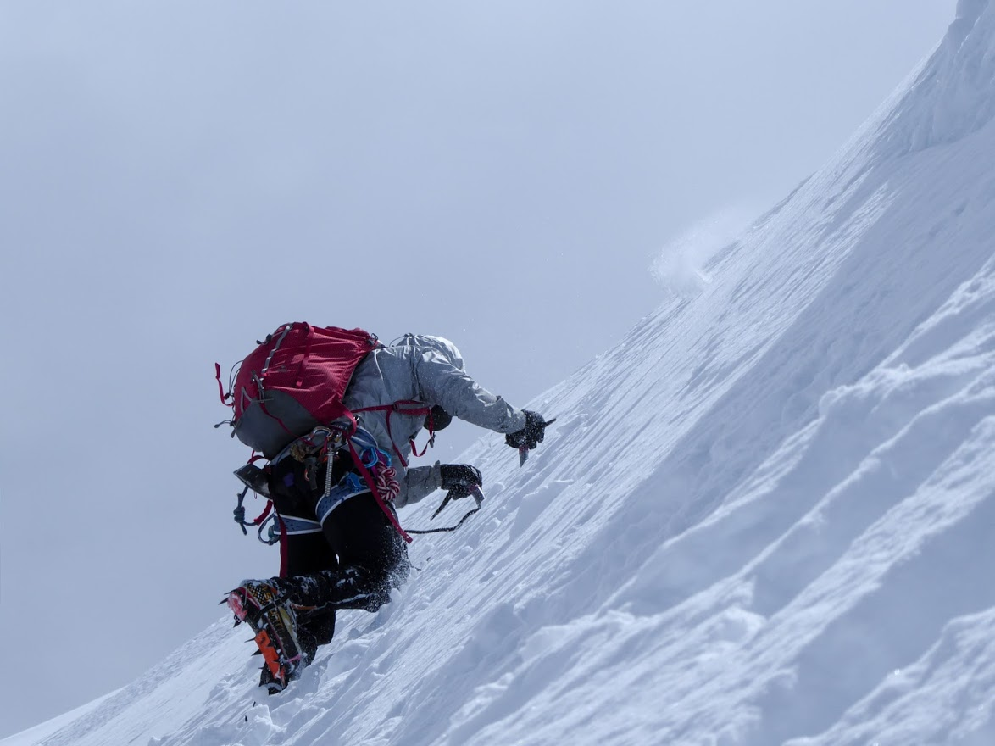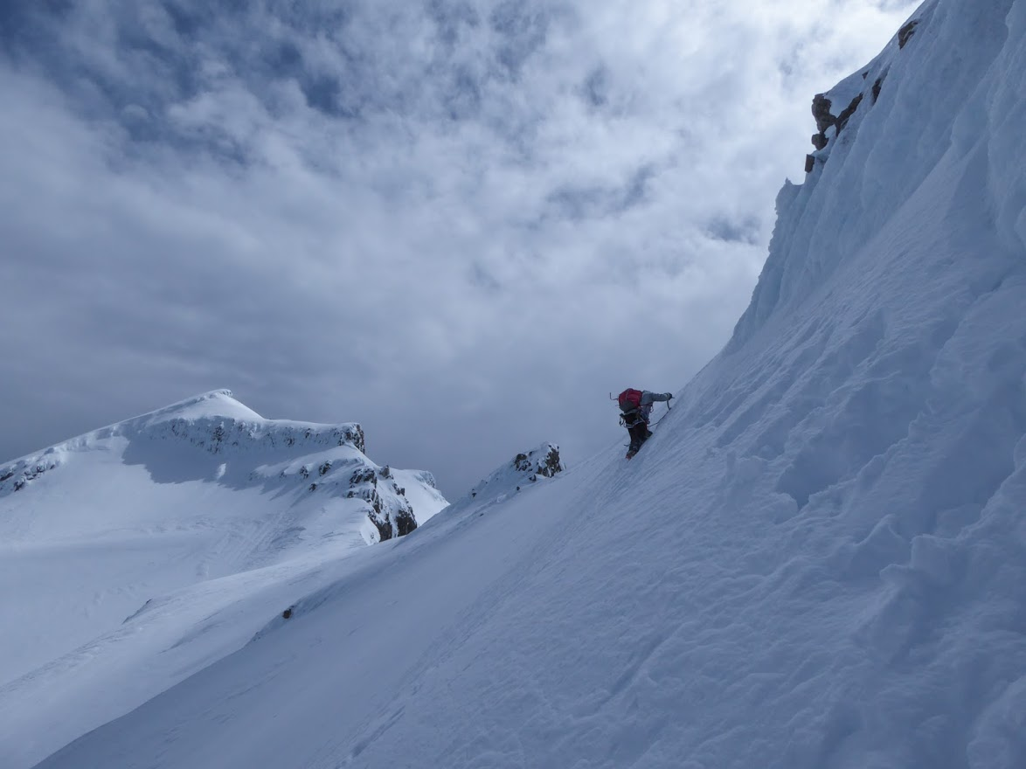

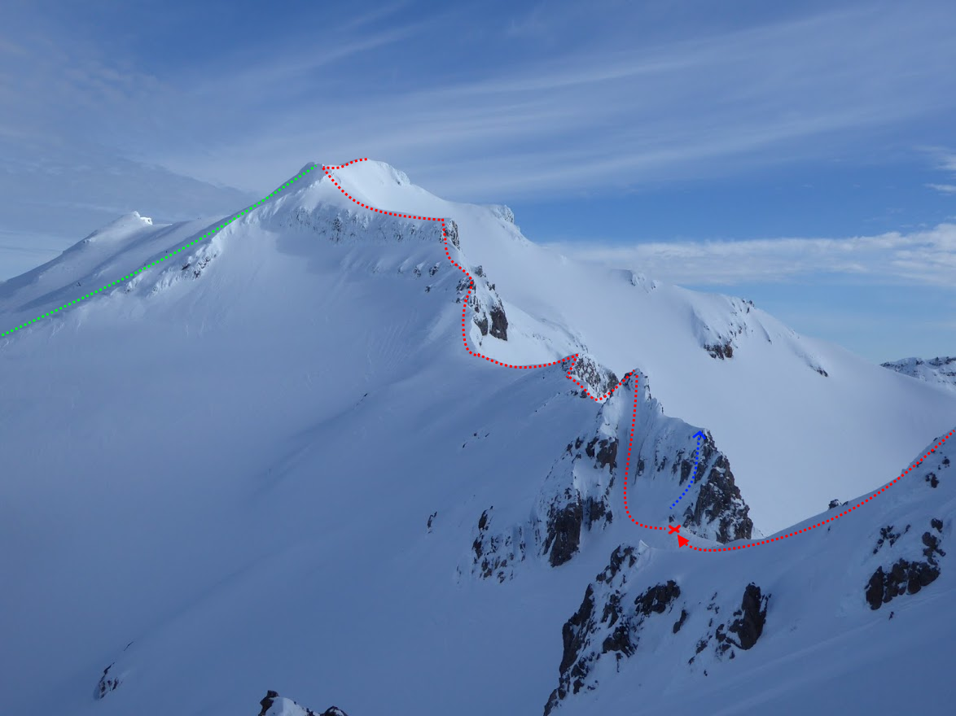

It looked like it would go, but it wasn't a very confidence inspiring solo. 8m or so of rotten, 80deg rime, with the Mangaeheuhu and Wahianoa dropping away rapidly underneath, but made somewhat less strenuous in places by the ability to chimney slightly between the rime bulges. It was clear that the rope needed to come out. Even if one of us got up there safely, who knows how much of the rotten ice would be left by the time the last person had to climb up.

We bashed in a topclip and with wary excitement, I tied in and charged up the rime. It was a delicate lead - as most rime climbing tends to be. Swinging as hard and as gentle as you dare, for fear of the entire thing breaking off or your placements randomly blowing and having to hold on with what little remains. I had to be very careful to keep my placements far apart, so that the dinner plates from whacking would leave my other placements uncompromised. It was no surprise when a gentle whack in search of a confidence inspiring pick sent a beach ball sized chunk of rime down range. In an airy bridge between rime bulges I attempted to place our lucky ice screw, but all options inspired no confidence - with no amount of digging helping. After some engaging climbing, I hauled myself over the top bulge, sinking my axes into the solid hero ice in the gully above. It was nice to be climbing such a predictable medium after the SBRRI3. My excitement was moderately tempered as I traversed under a rime tunnel, losing the ability to swing my axes with any meaningful force for fear of shattering the ice behind them, and getting peeled off. Eventually I got to the easier ground on the ridge to Tahurangi, bringing up Kyle and Lucy on a topclip equalised with a bomber axe, putting the rope away.

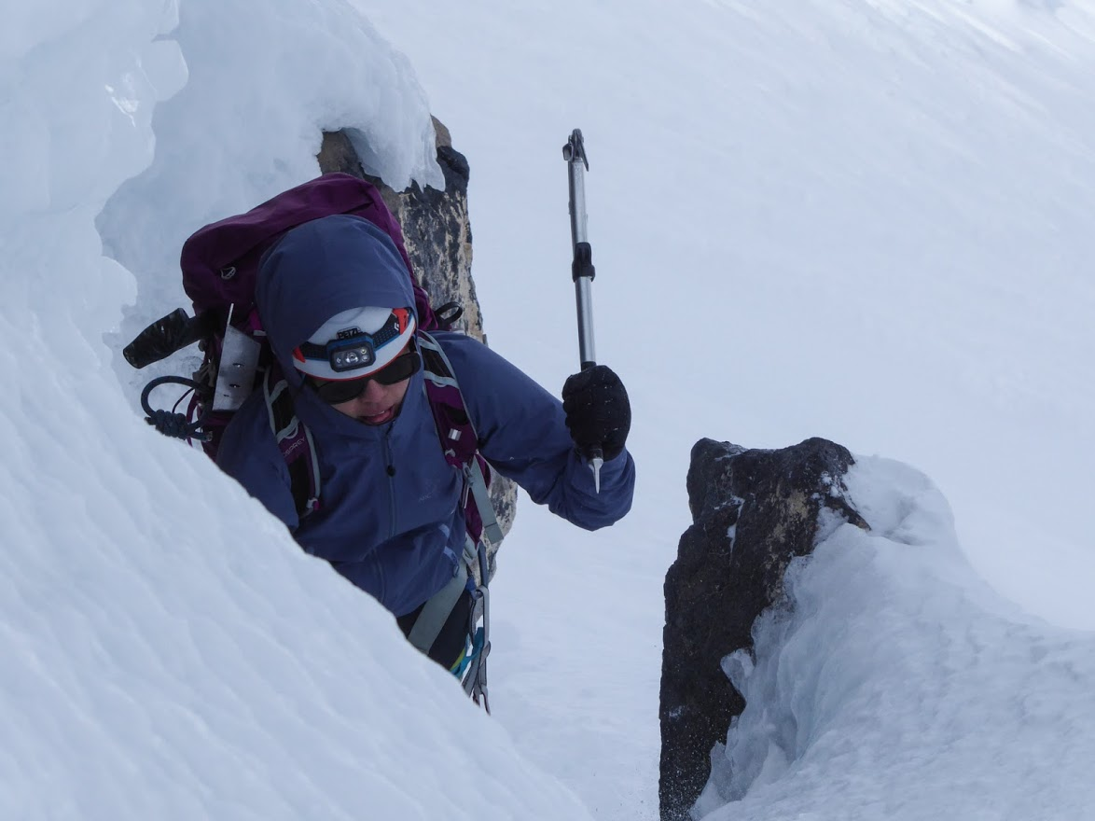

*“ATTACKING” - Lucy, probably.*

What remained was the relatively boring but exposed walk along the ridge to Tahurangi. We almost couldn't be bothered, but did it anyway, enjoying the lovely wind that comes along with being on the highest point on the highest mountain on the island. The clag started coming in as well as we descended skyline ridge to the skifield, a surprisingly engaging descent featuring blue ice covered (or not) in varying thicknesses of powder snow, at an awkward and inconsistent angle between frontpointing and flat footing. 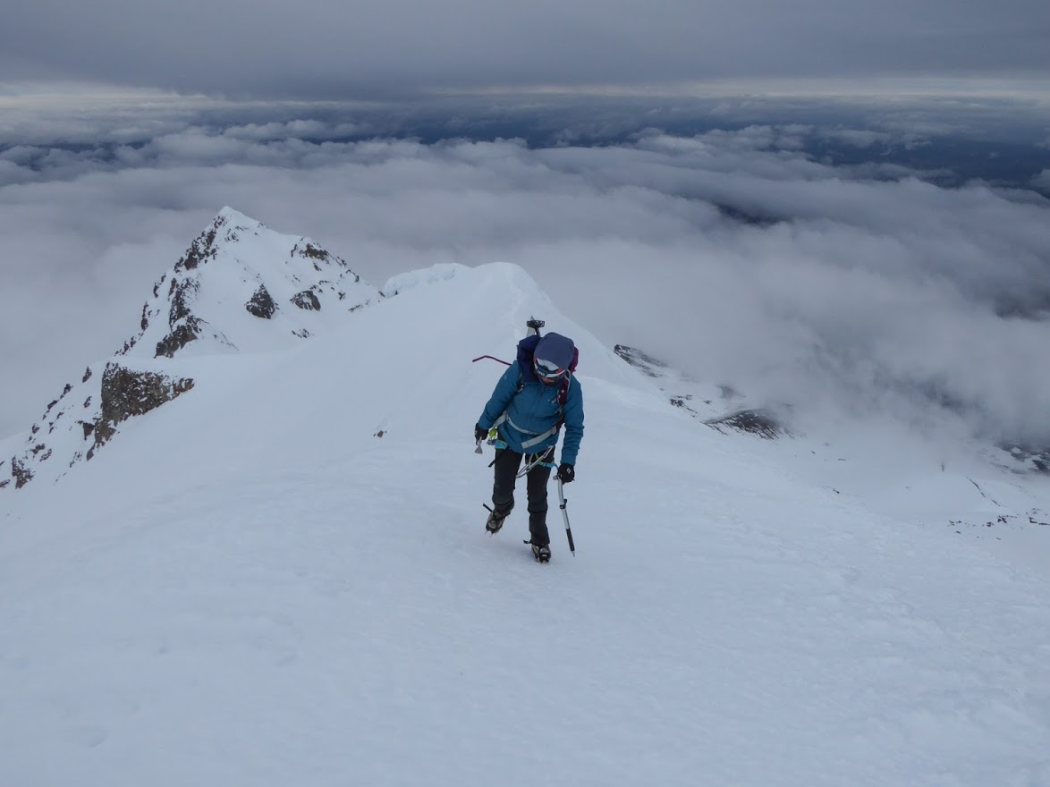

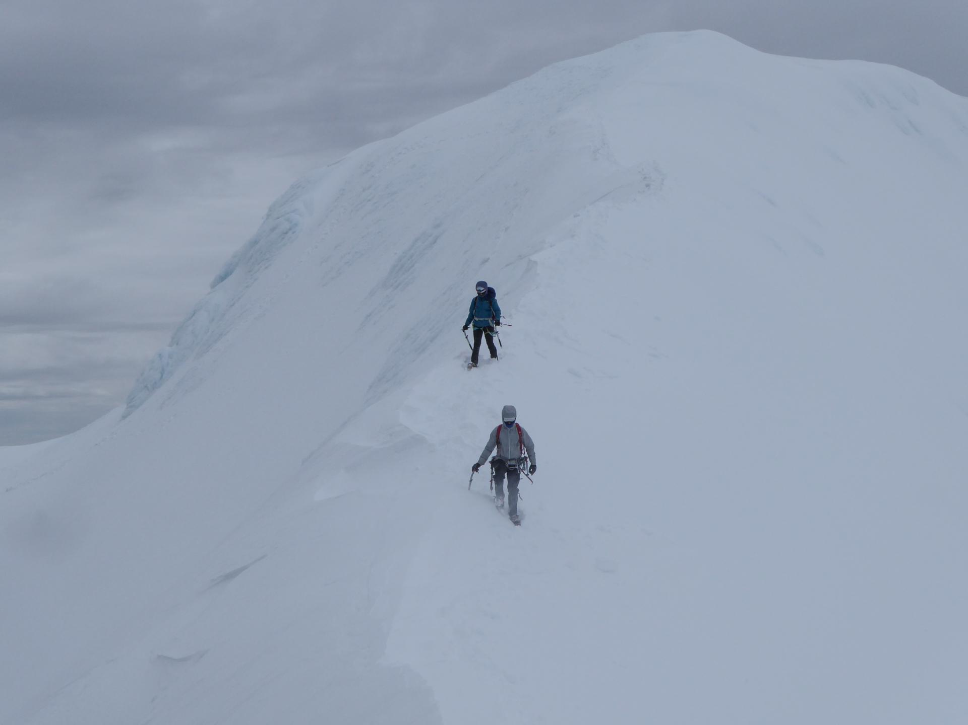

After all manner of wacky hijinks, with many skiers and snowboarders wading through the powder above the ski field in a seeming attempt to summit, we were back at the high noon at 2:30PM, greeted by some very confused mountaineers who didn't have packs and strapped planks to their feet and yote themselves down the mountain. Also, chocolate.

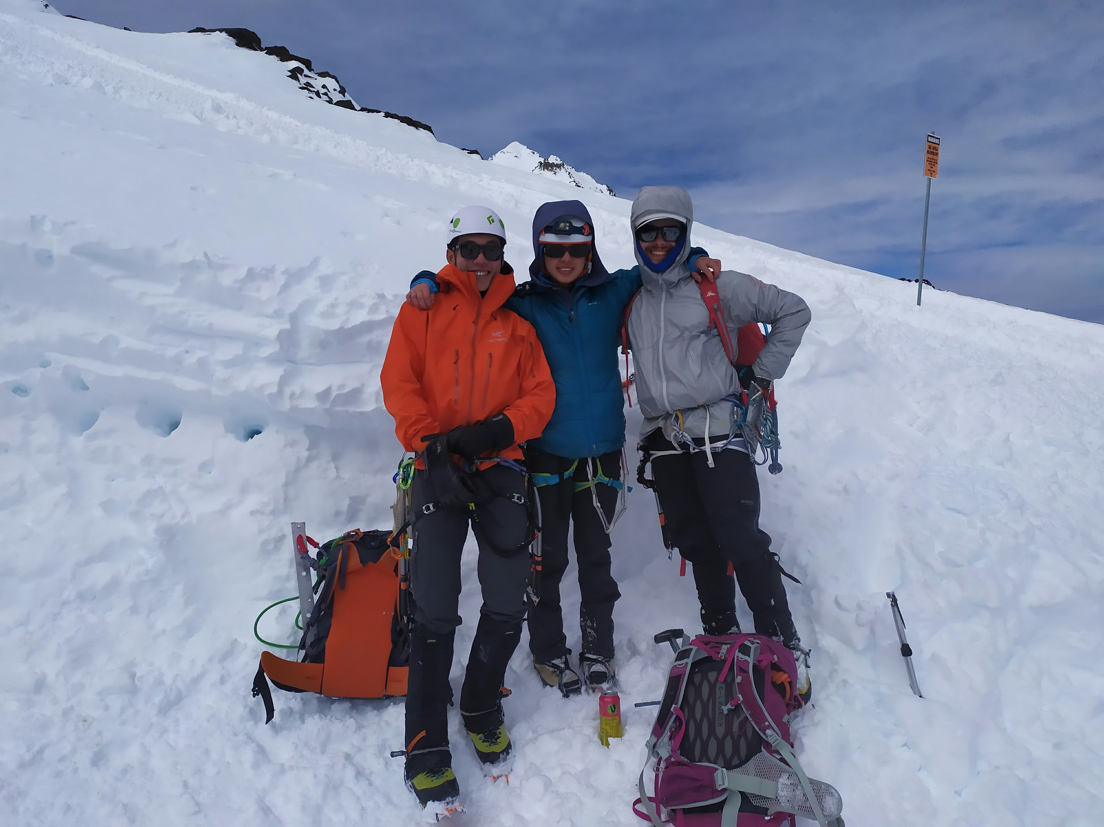

After pointing out the hazards of the limited visibility, the sheer volume of skiers and all of the spiky things attached to us, RAL begrudgingly gave us a lift half way down to the carpark. The next half proved to provide outrageously good boot skiing (but apparently too crap for actual skiing) so I ended up getting to the carpark a bit ahead of Kyle and Lucy (and apparently faster than people on the lifts) where I immediately passed out.

*The Author, BTFO.*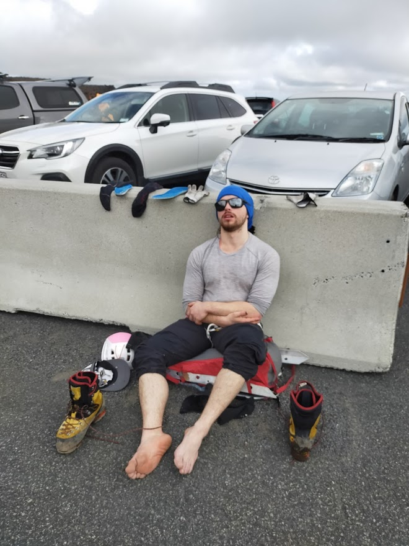

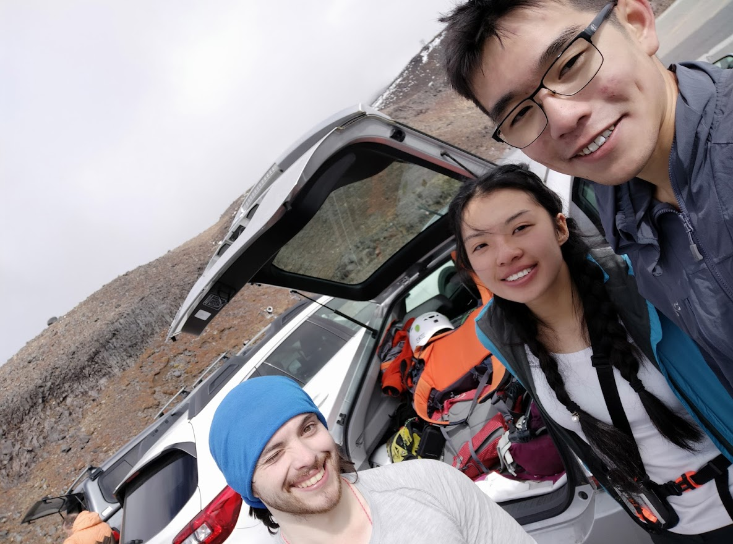

*Obligatory car selfie*

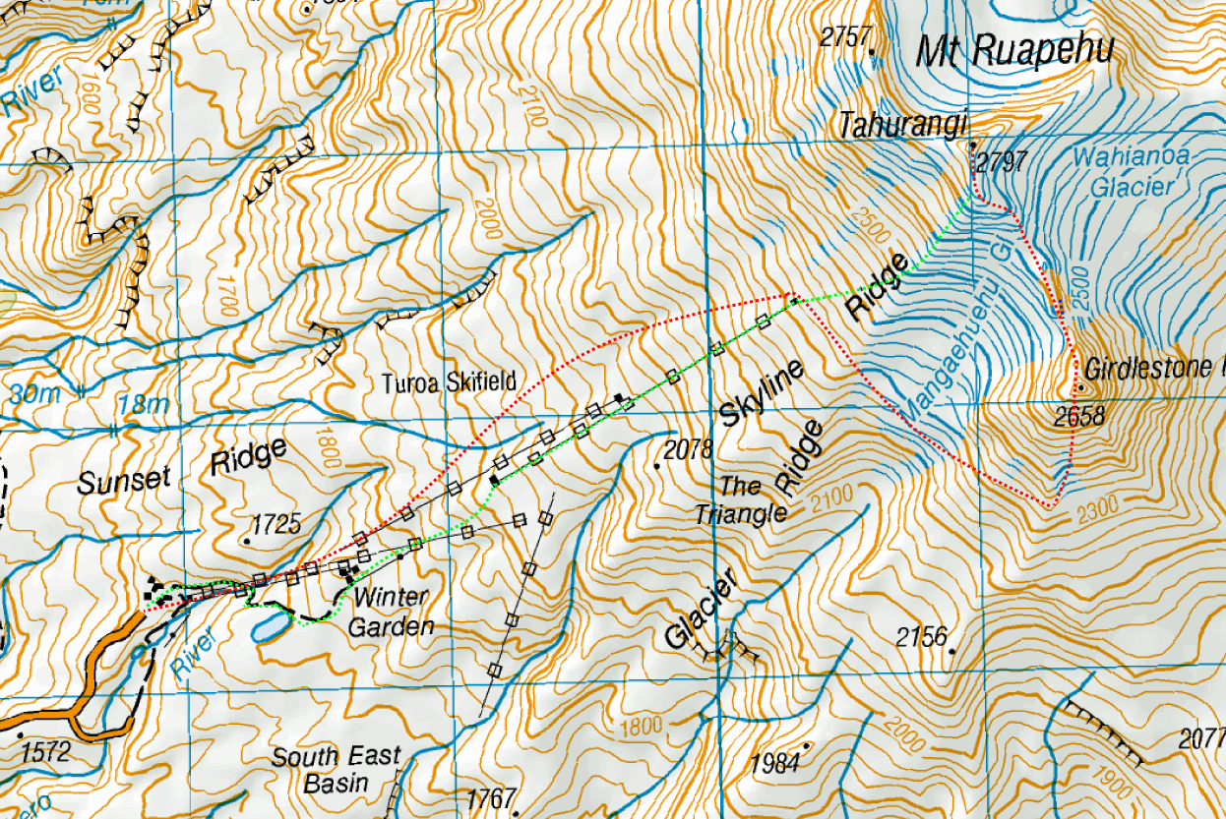

*Our route up in red, descent in green.*